Sales Prediction Using Python

Data set :
https://www.kaggle.com/code/ashydv/sales-prediction-simple-linear-regression/input

Code :
#Task 4 :
import pandas as pd
import matplotlib.pyplot as plt
import seaborn as sns
from sklearn.model_selection import train_test_split
from sklearn.linear_model import LinearRegression
from sklearn.metrics import mean_absolute_error, mean_squared_error, r2_score
df = pd.read_csv("advertising (1).csv")
print("First Five Rows:")
print(df.head())
print("\nDataset Shape:", df.shape)
print("\nColumn Names:")
print(df.columns)
print("\nMissing Values:")
print(df.isnull().sum())
print("\nStatistical Summary:")
print(df.describe())
# Correlation Heatmap
plt.figure(figsize=(6,5))
sns.heatmap(df.corr(), annot=True, cmap="YlGnBu")
plt.title("Correlation Matrix")
plt.show()
# TV vs Sales
plt.figure(figsize=(6,4))
sns.scatterplot(x="TV", y="Sales", data=df)
plt.title("TV Advertising vs Sales")
plt.show()
# Radio vs Sales
plt.figure(figsize=(6,4))
sns.scatterplot(x="Radio", y="Sales", data=df)
plt.title("Radio Advertising vs Sales")
plt.show()
# Newspaper vs Sales
plt.figure(figsize=(6,4))
sns.scatterplot(x="Newspaper", y="Sales", data=df)
plt.title("Newspaper Advertising vs Sales")
plt.show()
X = df[["TV", "Radio", "Newspaper"]]
y = df["Sales"]
# Split Dataset
X_train, X_test, y_train, y_test = train_test_split(
X,
y,
test_size=0.2,
random_state=42
)
model = LinearRegression()
model.fit(X_train, y_train)
y_pred = model.predict(X_test)
print("\nModel Performance")
print("R2 Score :", round(r2_score(y_test, y_pred), 3))
print("Mean Absolute Error :", round(mean_absolute_error(y_test, y_pred), 3))
print("Mean Squared Error :", round(mean_squared_error(y_test, y_pred), 3))
result = pd.DataFrame({
"Actual Sales": y_test.values,
"Predicted Sales": y_pred.round(2)
})
print("\nActual vs Predicted Sales")
print(result.head(10))
plt.figure(figsize=(6,4))
plt.scatter(y_test, y_pred)
plt.xlabel("Actual Sales")
plt.ylabel("Predicted Sales")
plt.title("Actual vs Predicted Sales")
plt.show()
new_data = pd.DataFrame({
"TV": [150],
"Radio": [25],
"Newspaper": [20]
})
predicted_sales = model.predict(new_data)
print("\nPredicted Sales for New Advertisement Budget:")
print(round(predicted_sales[0], 2))
coefficients = pd.DataFrame({
"Feature": X.columns,
"Coefficient": model.coef_
})
print("\nFeature Coefficients")
print(coefficients)
print("\nIntercept:", model.intercept_)

Output :
First Five Rows:
TV Radio Newspaper Sales
0 230.1 37.8 69.2 22.1
1 44.5 39.3 45.1 10.4
2 17.2 45.9 69.3 12.0
3 151.5 41.3 58.5 16.5
4 180.8 10.8 58.4 17.9

Dataset Shape: (200, 4)

Column Names:
Index(['TV', 'Radio', 'Newspaper', 'Sales'], dtype='object')

Missing Values:
TV 0
Radio 0
Newspaper 0
Sales 0
dtype: int64

Statistical Summary:
TV Radio Newspaper Sales
count 200.000000 200.000000 200.000000 200.000000
mean 147.042500 23.264000 30.554000 15.130500
std 85.854236 14.846809 21.778621 5.283892
min 0.700000 0.000000 0.300000 1.600000
25% 74.375000 9.975000 12.750000 11.000000
50% 149.750000 22.900000 25.750000 16.000000
75% 218.825000 36.525000 45.100000 19.050000
max 296.400000 49.600000 114.000000 27.000000
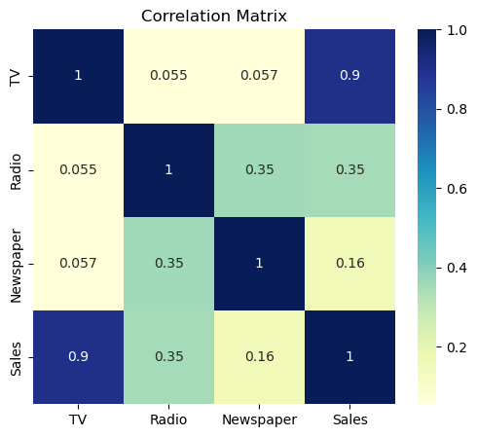
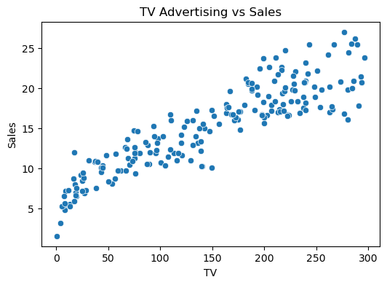
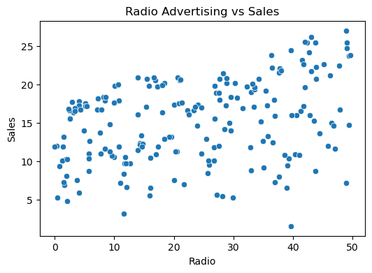
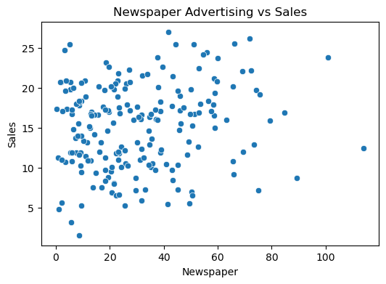

Model Performance
R2 Score : 0.906
Mean Absolute Error : 1.275
Mean Squared Error : 2.908

Actual vs Predicted Sales
Actual Sales Predicted Sales
0 16.9 17.03
1 22.4 20.41
2 21.4 23.72
3 7.3 9.27
4 24.7 21.68
5 12.6 12.57
6 22.3 21.08
7 8.4 8.69
8 16.5 17.24
9 16.1 16.67
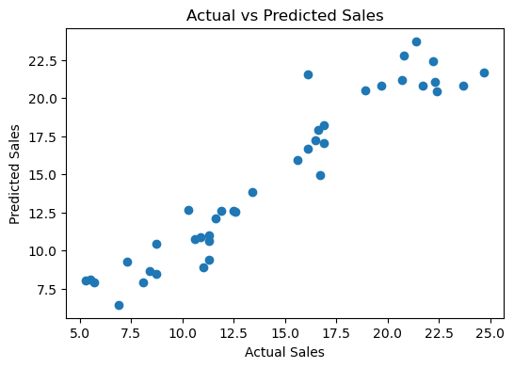

Predicted Sales for New Advertisement Budget:
15.5

Feature Coefficients
Feature Coefficient
0 TV 0.054509
1 Radio 0.100945
2 Newspaper 0.004337

Intercept: 4.714126402214131

